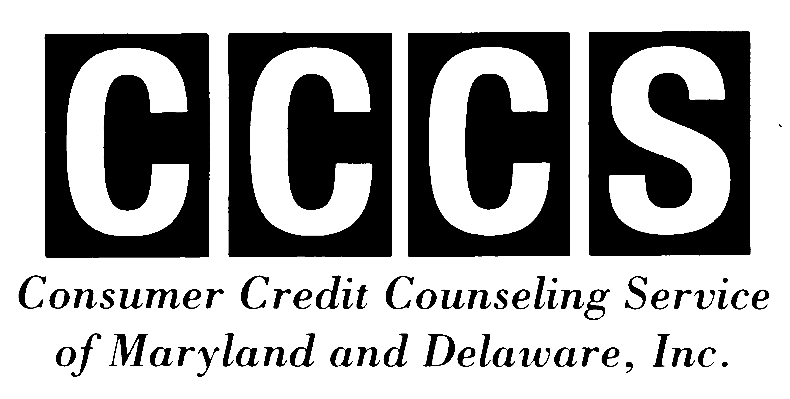
FOR IMMEDIATE RELEASE Contact Information:
February 16, 2010 NANCY STARK
410.357.0614 (phone)
410.357.0613 (fax) nstark@mind2medias.com
Helping people help themselves through Education, Financial Counseling and Debt Repayment
COUPLES & MONEY
How to Stop Fighting and Start Talking
(WILMINGTON, DE) According to many surveys, money is the most common topic that couples fight about. This isn’t surprising, given it represents so much — love, happiness, power, and prestige, and based on past experience, each of us has our own very unique view of how it should be used. Money may result in control issues if one partner in the relationship holds all the purse strings. It also may lead to heated arguments when couples encounter job loss or an unexpected financial windfall or if one partner has a gambling problem. But with patience, insight, and compassion, couples can work together to reconcile their money differences. Deanna Booker, Communications and Community Outreach Manager for local nonprofit Consumer Credit Counseling Service of MD & DE (CCCS), offers these tips for improving domestic harmony and gaining financial peace of mind:
- Learn how to communicate. Take the time to regularly talk with your partner about family finances. Don’t wait until a problem erupts; instead, schedule ongoing conversations where you review your current financial situation, discuss money issues, and identify common spending and saving goals. Booker advises, “During these discussions, it’s important to try to be open and nonjudgmental. Avoid playing the blame game.” If difficult issues or questions arise, it may help to write down your feelings before you actually talk about them with your significant other.
- Strive to understand your partner’s perspective. Depending on how couples grew up, they often have different attitudes about money. For example, one may be a “spender” while another is a “saver.” Some feel guilty about money; others are compelled to simply avoid the topic all together. Booker notes, “It’s common for opposites to attract. So you may have a person who can shop until they drop married to someone who counts every penny. As the years go by, even couples who start out on the same end of the spectrum may gravitate in opposite directions. When couples don’t understand or respect each others’ attitudes and point of view regarding finances, polarization and disagreement are likely to set in.”
- Divide up the financial workload just as you do other chores. When one person controls the couple’s finances, they also get stuck with the lion’s share of worry or responsibility. “Consider swapping financial chores,” Booker suggests. “For example, if one of you usually is responsible for balancing the checkbook or paying the monthly bills, trade off every few months instead. This will give each of you a chance to have control. You’ll also be surprised what you learn by walking in the other’s shoes.”
When couples maintain an open dialogue about their finances and work together to become fiscally fit, they also are more likely to gain financial security. As a focus on personal finance, Booker recommends these exercises:
- Set and stick to a budget. CCCS of MD & DE has an easy-to-use interactive budget form in the Financial Tools section of its website at www.cccs-inc.org. Couples who need help doing this can also call CCCS at 1-800-642-2227 for a free budget counseling appointment. Also track your spending and compare notes. That way you’ll both have a better idea of how you are putting your money to use.
- Work together to get organized. One way to do this is to create a family cash-flow chart. Booker explains how: “Using a standard calendar, list your paydays and the amount you expect to receive in your paycheck. Next, list which bills are to be paid out of each check. This eliminates the last-minute scrambling to meet payment due dates, and avoids costly overlimit and overdraft fees.” Also develop a system for organizing and retaining financial records. Since it’s tax season, this is the perfect time to shred what you don’t need and file what you do.
- Don’t be afraid to openly discuss your financial situation. If one of you has lost a job, it may affect your relationship and finances. Then brainstorm ways to cut expenses, so that you’re able to live within your means. If circumstances have changed, it’s irresponsible to continue spending as you did when both of you were employed.
- Find ways to increase family income. If you’re employed, but still need more income to live on, Booker advises, “Review your withholding allowances from your paycheck. Recently, many families who live paycheck-to-paycheck have received an income tax refund of over $2,000. Often, these are the very same people who struggle to make ends meet and could really use an extra $200 in their paycheck instead.” The IRS has a helpful page that will help you calculate your withholdings. Just go to www.irs.gov, type the words ‘withholding calculator’ into the search box, and follow the directions they provide. In a matter of minutes you’ll learn the appropriate number of withholding allowances for your situation.
- Find ways to save money. Having an emergency savings fund can help you avoid money arguments, because it provides a safety net for when unexpected expenses occur. Booker explains, “Even small changes in lifestyle can leave you with more money in your pocket. If you regularly eat out at work, bringing a lunch from home instead could leave you with an extra $100 to put into savings each month.”
- If you get an income tax refund, use it wisely. Catch up on any past due bills, put at least 10 percent into your savings - more if possible, and consider making needed repairs to the house or car.
Booker concludes, “Couples receive several benefits when they work together to achieve financial stability: They generally experience less stress and fight less, and this ultimately may lead to a happier, more secure relationship.” A recent Utah State University study found that marriages where couples work together to achieve financial harmony are 30 percent less likely to end in divorce.
####
Consumer Credit Counseling Service of MD & DE, Inc. (CCCS) is an accredited nonprofit agency that has served the local community since 1966. We promote economic self-sufficiency and provide help to individuals, families and communities through financial literacy education and credit and housing counseling. For further information about our vision, values, and services, please visit our website at cccs-inc.org. MD State License #14-01/ DE State License #07-01.

